A1.
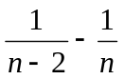 , 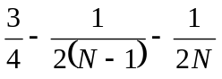

A2.
Prove by mathematical induction.

A3.
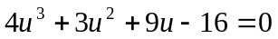 , 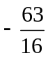

A4.
(i) 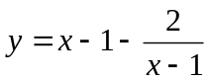 , Asymptotes: 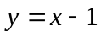, 
(ii) The function is increasing.

B1.
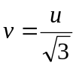 , direction = 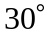

B2.
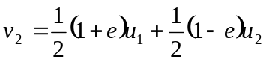 , 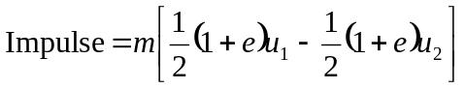

B3.
, 